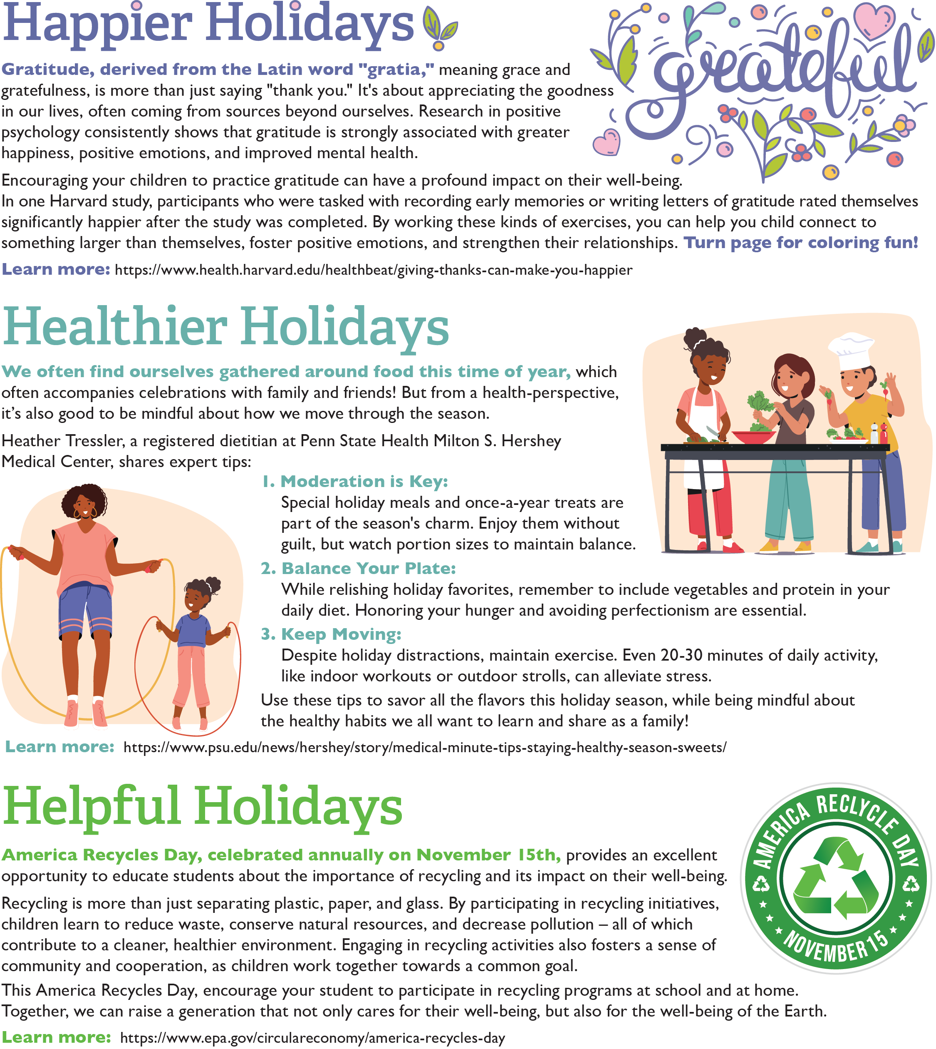

<https://www.conagrafoodservice.com/>

<https://rethinkschoolmeals.com/>

<https://www.epa.gov/circulareconomy/america-recycles-day>

<https://www.health.harvard.edu/healthbeat/giving-thanks-can-make-you-happier>

<https://www.psu.edu/news/hershey/story/medical-minute-tips-staying-healthy-season-sweets/>

<https://www.conagrafoodservice.com/>

<https://rethinkschoolmeals.com/>